P101/1749G/21

NICODEMUS MALOMBE

BIT 440: LOGIC PROGRAMMING

ASSIGNMENT

1.

A. If the query ? – onlychild(y) is executed on the SWI-Prolog prompt, what will be the output? [2 marks]

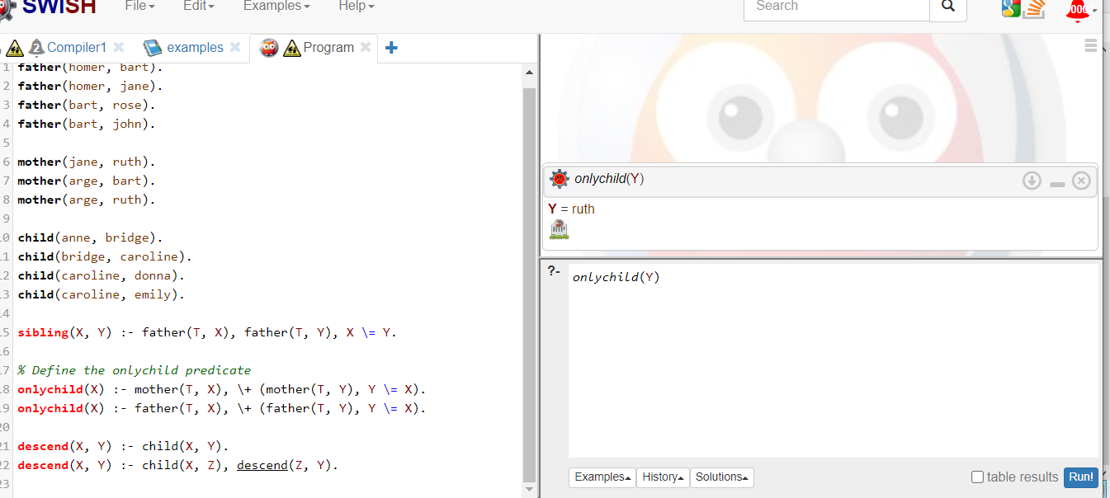

B. If a call to the query ?-descend(X, Y) is made, will it terminate or not? Explain your answer. [3 marks]

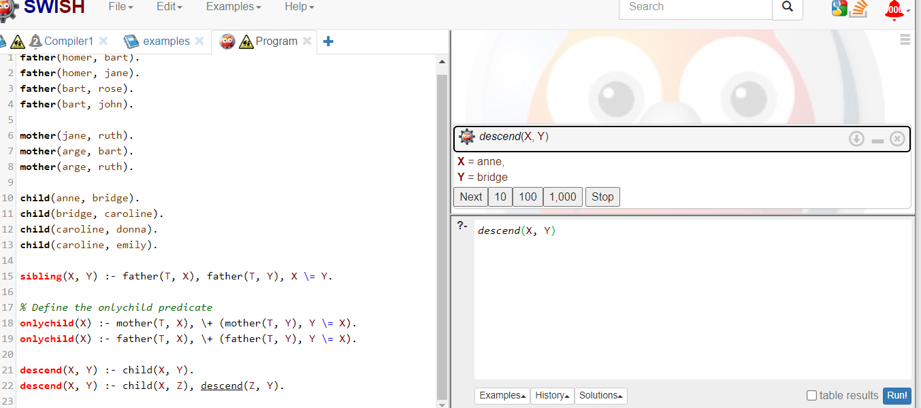

C. Provide a modification for the descend(X, Y) clause so that a call to descend(X, Y) will always terminate. [5 marks]

The modified descend/2 predicate is:

descend(X, Y):- child(X, Y). % Base case

descend(X, Y):- child(X, Z), descend(Z, Y). % Recursive case

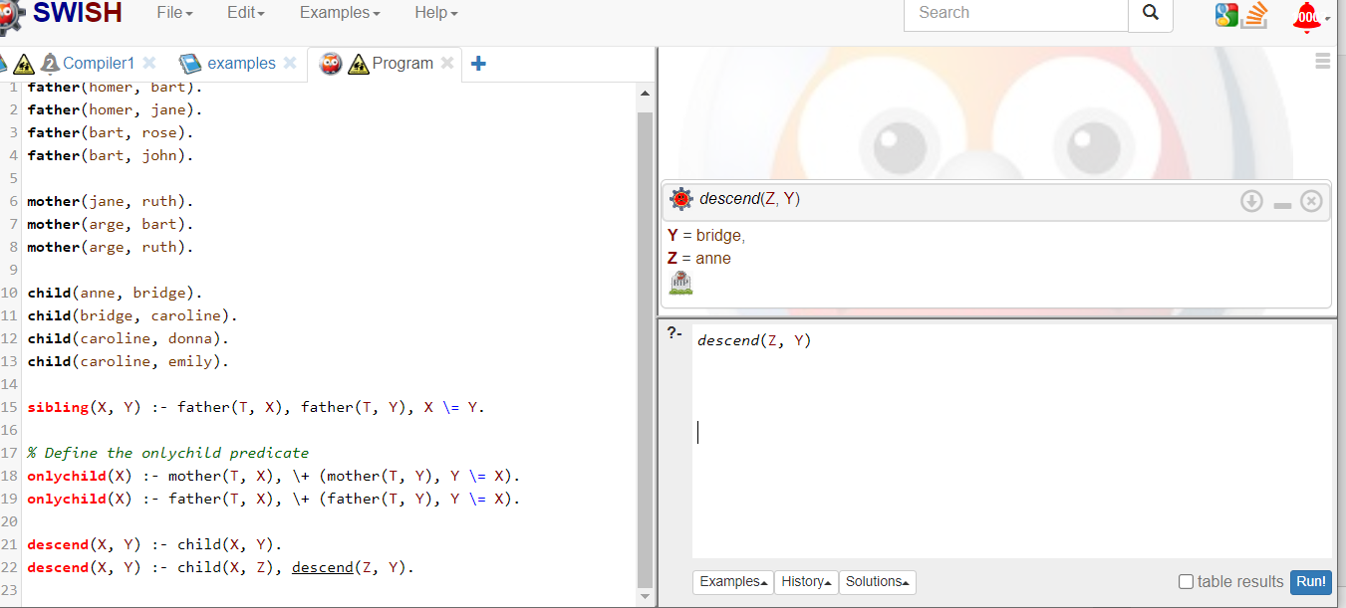

2. State the three factors that may affect the running efficiency of recursive rules in Logic Programming.

1. Recursive rules: recursive rules, with some structures being more efficient for certain types of recursive operations

2.Recursion Depth: Deep recursion can lead to increased memory usage and longer execution times, potentially causing performance issues..

3.Recursive Call Optimization: Poor optimization of recursive calls can lead to increased overhead and slower execution times, reducing the overall performance of the program.

3. Which line(s) would produce errors when the above Prolog program is compiled and explain why. [3 marks]​

* Line 1: Lions (zakayo). - This line contains a syntax error because the parentheses are not properly closed.
* Line 3: tiger(jerry). - This line contains a syntax error because the period should be replaced with a comma.
* Line 10: search(X)-: person(X)),\+(loves - This line contains a syntax error because the closing parenthesis is missing, and the predicate name is not properly defined.